

café Robot

A Plan to navigate a robot to correctly deliver coffee



Farah Aymen Mounir

194233

AI-Group 1

Table of Contents

Problem Description 2

Problem representation 3

Approaches 4

First Approach: Spaces 6

Second Approach: Graph 8

Third Approach: Grid 15

Plans and Assumptions 19

Problem Solution 20

Computer representation 21

Functions 22

Function: Move_to (X, Y) 22

Function: Open Door(D) 23

Function: Close Door(D) 24

Function: Deliver_Coffee (O, T) 25

Function: Update_Locations (TA, T) 27

Function: PickUp_Coffee (O): 28

*Example*: 28

Failure Scenarios 29

Scenario 1 29

Scenario 2 30

Scenario 3 31

Scenario 4 32

Final Representation 33

References 34

# Problem Description

The problem we are approaching is planning how a robot can deliver coffee to people efficiently. There is a classroom and a TA’s office that total include twenty-one person who can potentially need coffee. The problem’s dimensions are present in how many cups the robot can hold at once, how and how many orders it can fulfil, how the robot will deliver the coffee, what if a TA changed his place of seating, what happens in case of an error and how it can be handled, and what algorithm that will be used for the robot to plan its path to reach its goal. Another problem the robot can face is how it will deal with doorways since it will have to open the door if closed. There are many approaches that can be executed to fulfil the robot’s goal of delivering the coffee, therefore, these approaches are needed to be explored and choose the best upon them regarding the efficiency, speed, and risk of failure. The initial state is that the robot is in the Café with the cups of coffee to be delivered to TAs or Doctors. The goal state is for the robot to be back in the café with the coffee successfully delivered.

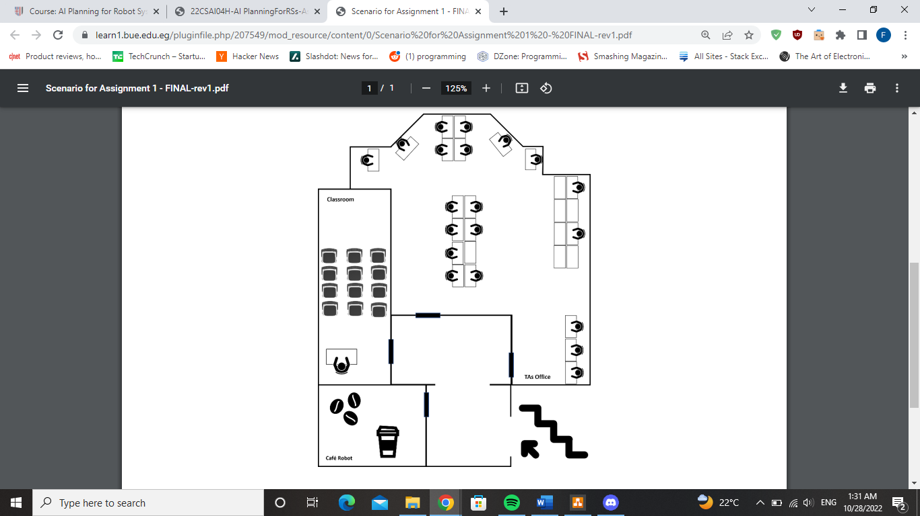

Figure (1): Space covered by the robot

# Problem representation

Representing the problem in a computer system can be done in several approaches, but the objective is to reach which approach is best to execute. The robot will carry at maximum 4 cups a time. The problem is also present in whether the robot will deliver the cups using the first come first serve method or using shortest path. It will use the shortest path either way, but in the first come first serve method, it will pick the shortest path to reach its goal which in this case will be the first order. While using the shortest path method, it will globally pick the shortest path that fulfils all orders regardless of which order came up first. Also, the representation of the doorways needs to be planned, especially on how the robot will open the door.

## Approaches

Regardless of the approach that will be taken, the main logic that the robot will deliver the coffee will go as follows: the robot will have predefined data where it knows which TA sits at which table, and when the TA orders the coffee, it will check his current location (which table he is sitting on) and deliver the coffee to this location. This will help the robot to keep track of where each TA sits in case a TA changes the area he sits at. In case the TA changes his sitting place, he will notify the robot of the change, so the robot can update its data. This data can be represented as a dictionary that maps each TA to the table he is sitting at:

Map = {

T1: TA1,

T2: TA2,

T3: TA3,

T4: NA,

T5: TA4,

T6: TA5,

T7: NA,

T8: NA,

T9: NA,

T10: NA,

T11: TA6,

T12: TA7,

T13: TA8,

T14: TA9,

T15: TA10,

T16: TA11,

T17: TA12,

T18: TA13,

T19: TA14,

T20: TA15,

T21: TA16,

T22: TA17,

T23: TA18,

T24: NA,

T25: TA19,

T26: TA20,

T27: DR

}

Using this method, if a TA or the Dr changes his place, leaves, etc., the robot will be notified by them and updates the dictionary. After looking at the dictionary, the robot will determine the location that will become his goal to reach, then it will execute the algorithm that will bring it there.

### First Approach: Spaces

First, we will represent the rooms and doorways into spaces. Each door will have a space from each side. Each table will have its own space so the robot will know which TA to deliver his coffee to. Regarding the coffee room, there will be a space for the coffee maker where the robot receives the coffee from. Also, there will be a space for the table where the professor sits in the classroom. The corridor will be represented as one whole space. The final layout of the environment will be as follows:

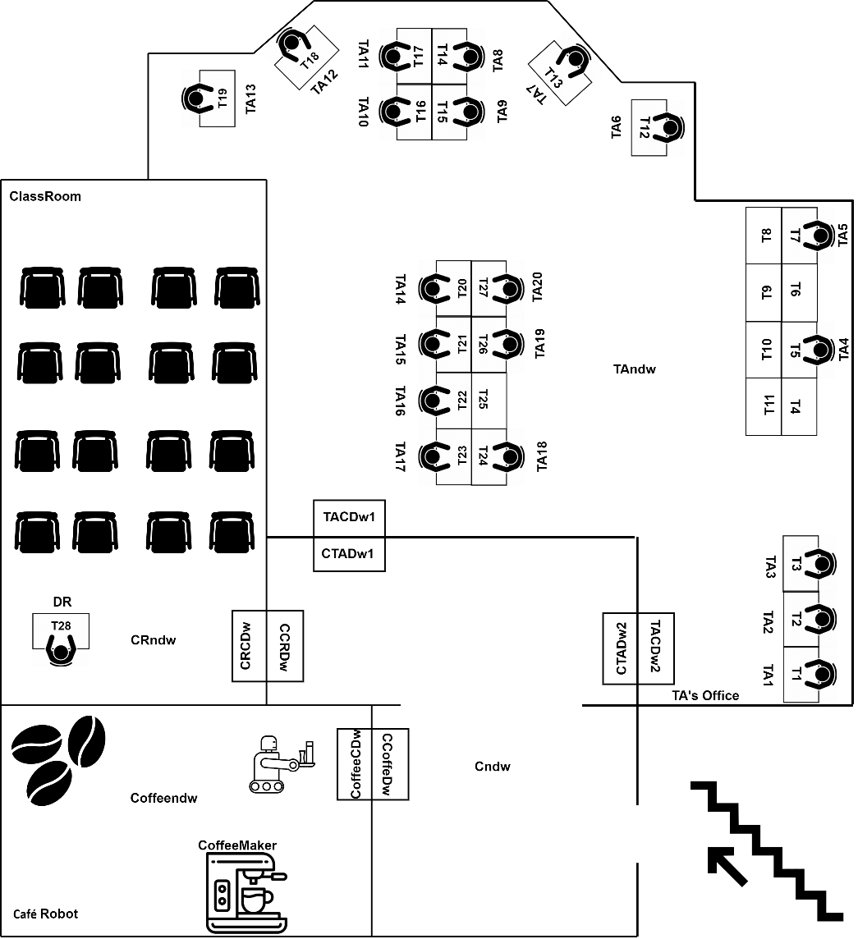

Figure (2): Environment composed of spaces

We will be representing the environment as a list to represent the spaces and their connections to each other. The corridor area in front of the coffee place, the TA’s office and the classroom will be represented as one space “Cndw”. Each door is represented as two spaces for each side of the door. For example, if the space is going from the corridor to the classroom, then the naming convention will be first the symbol of the corridor ”C”, then the symbol of the classroom ”CR”, then finally, the symbol that represents that this is a doorway “dw”. So, the notation for the doorway is where the robot is coming from, then where it is going to, then symbol that represents it’s a doorway. The robot will be delivering to the TA or Dr that orders coffee, so the robot will check where the person that ordered in which space and deliver it to him. For example, if TA10 orders coffee, the robot gets notified, then checks where TA10 sits which is T15, so, the robot will execute its algorithm to deliver to that space.

Environment = [

[environment, [connections, [[corridor, cafe], [corridor, classRoom], [corridor, TAsOffice]]]],

[corridor, [connections, [[Cndw, CCoffeeDw], [Cndw, CTADw1], [Cndw, CTADw2], [Cndw, CCRDw]]]],

[cafe, [connections, [[coffeeMaker, coffeendw], [coffeeCDw, coffeendw], [coffeeCDw, CCoffeeDw]]]],

[classRoom, [connections, [[T23, CRndw], [CRndw, CRCDw], [CRCDw, CCRDw]]]],

[TAsOffice, [connections, [[T1, TAndw], [T2, TAndw], [T3, TAndw], [T4, TAndw], [T5, TAndw],

[T6, TAndw], [T7, TAndw], [T8, TAndw], [T9, TAndw], [T10, TAndw],

[T11, TAndw], [T12, TAndw], [T13, TAndw], [T14, TAndw], [T15, TAndw],

[T16, TAndw], [T17, TAndw], [T18, TAndw], [T19, TAndw], [T20, TAndw],

[T21, TAndw], [T22, TAndw],

[TAndw, TACDw1], [TAndw, TACDw2], [TACDw1, CTADw1], [TACDw2, CTADw2]]]]

]

Traversing through these complicated lists to reach the goal, checking if a condition is fulfilled, or altering in the environment will be complex, and can take a huge time complexity; due to the many nested loops that will be implemented.

### Second Approach: Graph

Another approach that can be applied that is better than the previous one. Instead of putting the environment in a list of lists, it can be represented as a graph composed of nodes and edges. The environment can be as follows:

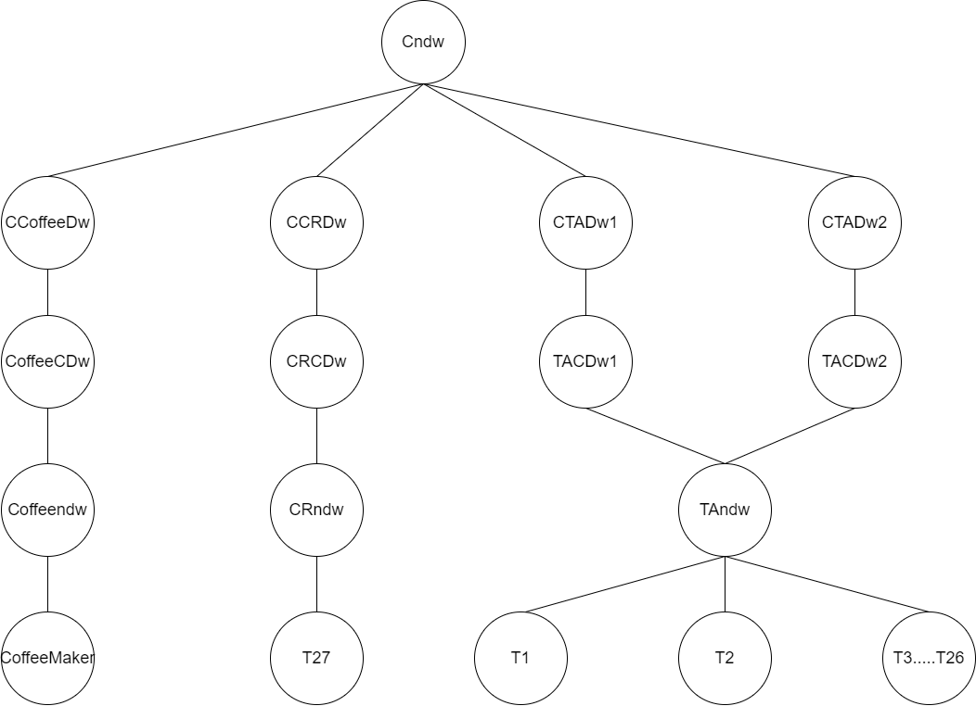

Figure (3): Environment as a graph

Each space that was represented in the list is represented as a node in the graph. The connections are also represented as edges that connect the nodes together forming the graph above. As known, a graph can be navigated through many algorithms like Breadth-First Search (BFS), Depth-First Search (DFS), Dijkstra¸ A*, etc… These algorithms can help in defining the path to the goal that the robot will take.

#### Breadth-First Search (BFS)



Figure (4): Traversing graph using BFS

Breadth first search is an algorithm that navigates through the tree level by level. It traverses from left to right through the whole level before it expands to the next one. For example, if the robot needs to deliver coffee to one of the tables at the TA’s office, for example, T15. The algorithm will first traverse from left to right on all nodes on the same level trying to reach the goal space. So, it will first go through the first level, but it won’t find the goal node. Then, it will expand to the next level and so on until the goal node is reached. The complexity of the Breadth-First Search is O (N + E) where N is the number of nodes and E is the number of edges [1].

#### Depth-First Search (DFS)



Figure (5): Traversing graph using DFS

Graphs can be navigated through Depth-First search were first it traverses through the whole depth of the tree then track back to the source node. For example, if the robot is trying to deliver coffee to Table 27 (to the Doctor), the algorithm will search from the branch on the left until it reaches the leaf node. When it doesn’t find the goal state, it will track back and move onto the next branch and so on, until it will finally reach the node T27 which is the goal. The complexity of the Depth-First search is O (N + E) where N is the number of nodes and E is the number of edges [2].

The problem with the graph representation is that it is not weighted, and it will not accurately determine the shortest path. For example, If the robot had a queue of order to TA1 at T1 (Table 1) and it used DFS, the algorithm will find the path through the node of the first door. The problem is that the actual distance would have been shorter physically if the robot took the door that is directly in front of the table which is the second door (CTADw2). But, since the first door came first in the graph, it is the path that is taken, especially that the graph is not weighted. To make this representation more accurate, we can assume weights so that it will help the algorithm recognize that the other path would have been shorter and use A* or Dijkstra, but then again, if it was the other way around and the robot needed to deliver to a table nearer to the other door, it will mean that we need to shift the weights. Assuming weights in general will be inaccurate and not seconded by much evidence.

#### Dijkstra Algorithm



Figure (6): Example on using Dijkstra

Solving the shortest path problem can be done by weighting the graph. One algorithm to fit this kind of graph is the Dijkstra algorithm. In this algorithm, first each node’s weight is considered infinity until we expand from the source node and discover the weights of the neighbouring nodes. Then, it starts to arrange the nodes ascendingly according to those weights. Finally, it chooses the lowest weight and repeats the previous steps until it reaches the goal node [3]. The problem with the Dijkstra algorithm is that it is a greedy algorithm; it does not guarantee the optimal solution in all scenarios. A* might be the answer to this obstacle.

#### A* Algorithm

The A* algorithm is a faster solution that the Dijkstra because it uses heuristics [4].

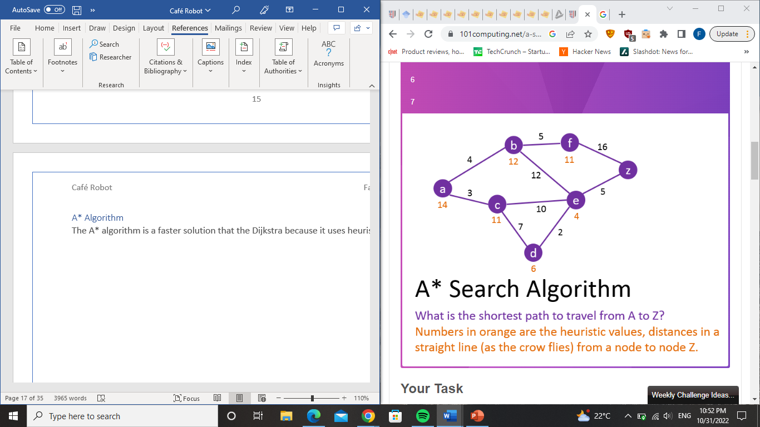

The total value is used to estimate the distance is the combination of the values of the actual cost and heuristic. The algorithm then selects the node of the lowest value. At each step, the total value gets recalculated to determine the next shortest path. We will also represent eh algorithm on grid and explore this approach.

To weight the graph, we need to make some changes in the graph and how the environment is divided. If the graph above is used, then the weights for each table node will be obsolete since it will always go through doorway 1; because it is the first branch in the graph. One solution is to make each table a separate node and get rid of the mid space that makes the whole office one space

As seen below, we got rid of “TAndw” node that represented the empty space in the office, instead the robot will measure the shortest path from the doorway to the tables directly. Last step that needs to be done is adding weights and heuristic values. This step will be based on assumptions and estimating distances between each node and the other. Generally, the robot will move from one node to the other then calculates the shortest path according to the weight of each path. The final graph will be as follows:

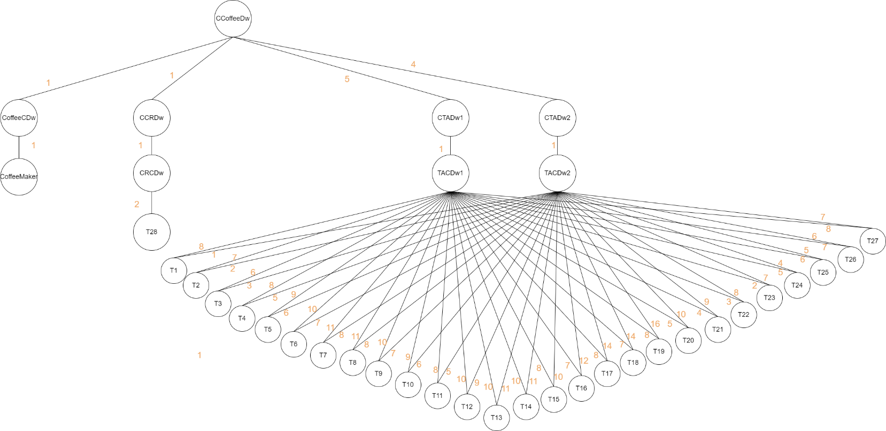 Figure (7): Weighted Graph representing the environment

Finally, the robot will start from the point of the coffee maker where it will take the orders, then it will start on taking the shortest path using A* to fulfil these orders based on the weights.

### Third Approach: Grid

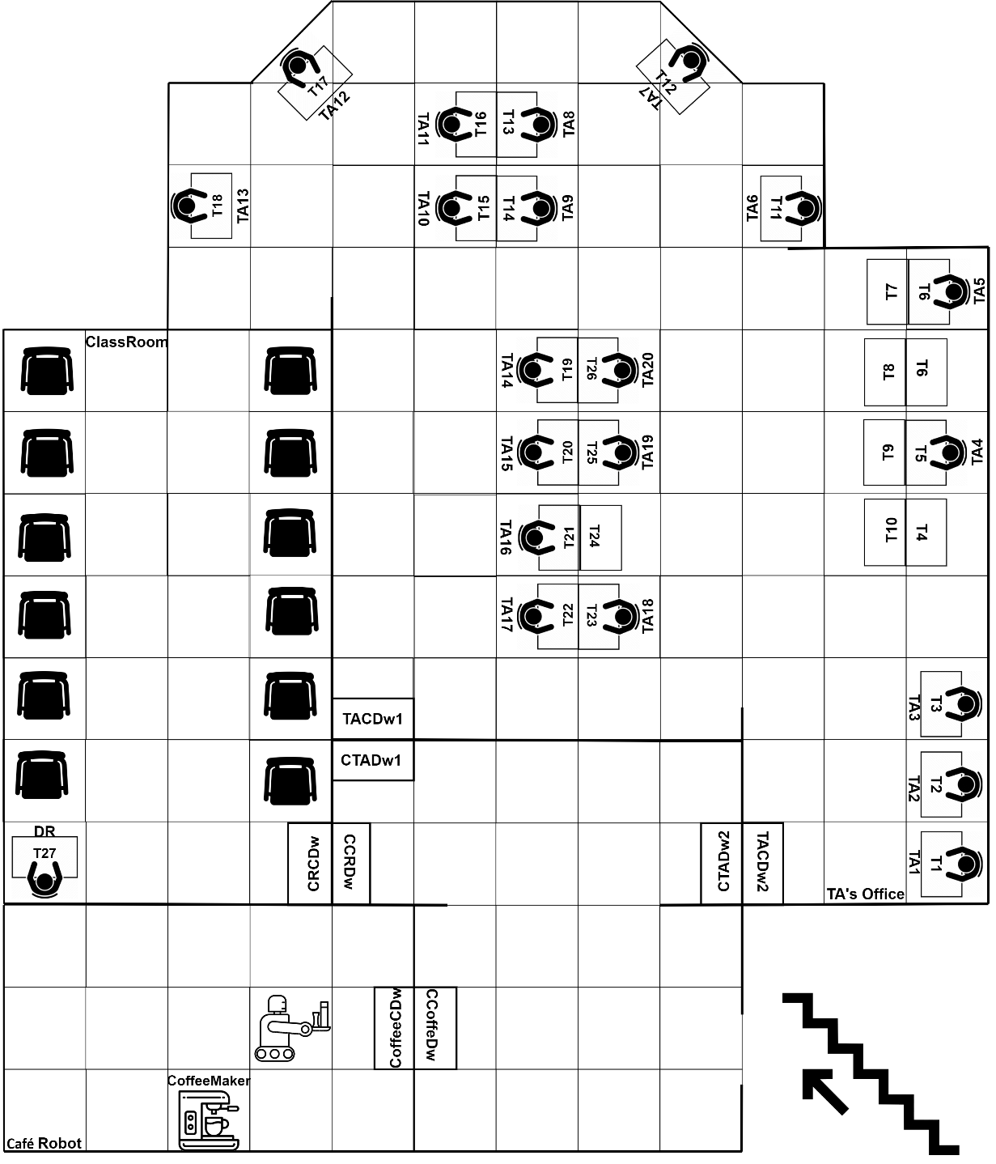

Figure (8): Grid representation of the environment

Another way to solve the problem of the weights and choosing the global shortest path, grids can help in doing so. Each step can form a weight that will help in calculating the cost and heuristic function while using the necessary algorithm. Each table is occupying a space and will be considered as an obstacle that the robot cannot stand at same space. Regarding the doorways, it will be a modifiable obstacle where when the robot arrives in front of it, it performs a function to open the door, so now it can pass through the door then the door gets closed.

#### A* Algorithm



Figure (8): A* algorithm example on a grid

A* algorithm is considered one of the best algorithms to reach the shortest path [5] . The environment will be represented as a bunch of coordinates then the algorithm will check at each step the lowest actual cost and heuristic (estimated cost) combined, and it will check if there’s an obstacle or not. The robot will stand on the square that is in front of the table to deliver the coffee to the table by placing the order on the table in front of it. When the robot needs to pass through the doorway, it will stand on the same square, calls for the function that opens the door, then opens the door to go through. Once the robot finished the orders it has, it will go back to its station whether to take more orders that were waiting in the queue or wait on new ones. Regarding the case where there are two tables are opposite to each other for example, table 6 and table 7, the robot will first check if there’s a space to go from behind the ordering table, if there’s space it will deliver the cup from there, but if there’s not, it stand in front of table so in that case it will stand at table 7 and extend its hand to table 6 to deliver the cup.

# Plans and Assumptions

We will assume that the robot can carry a maximum 4 cups to deliver. Also, it is assumed that the robot will have the ability to open the door so it can go through it. Also, the robot is assumed that once it gets the order, it will go to the coffee maker and press the appropriate button that will make the coffee ordered, then take the cup to deliver. The robot won’t wait until four orders are ordered so it can fulfil them, but once it gets an order or multiple of orders in a close time interval, then it will deliver them. If it received more than the capacity it can hold at once (which is four cups at a time), it will deliver the first four while the others wait in the queue and so on. We don’t need to assume the TA, or the Doctor need to stay at their place so the robot can deliver; because the robot will map the TA’s order or the doctor’s to the table he sits at and deliver it to the table so once the person -if he left- gets back, he will find his coffee delivered. The robot will have the map loaded onto its memory and with the help of its sensors it will know where the walls/obstacles/doors are so it won’t hit anything on the way of delivery, and it will know where it is going. At implementation, we will assume that the orders are already done, it will not be taken in real time. We will assume that the tables that the robot cannot reach from any side (for example table 6) then, it will deliver it from the table that is in front of it (table 7).

# Problem Solution

After exploring all approaches, the approach that was found suitable and will be used is the graph approach using the A* algorithm. The reason behind using the graphs, because it will be easier to represent while coding that the grid. The graph will be represented as each node while the grid will have to represent each square as a coordinate. With an environment this big, it will get more complex. The robot will have a queue of all the orders it gets. It will carry a maximum four cups at a time. It will have the ability to open the door and pass through the doorway. The robot will check the set of orders to see the shortest order to fulfil at a time so it will cut the shortest path generally. The robot will arrive at the chunk (set of tables) and deliver the coffee to the appropriate table. We will use A* algorithm because it is faster and more efficient that the Dijkstra. The time complexity of the Dijkstra is O(v^2) and it is considered a greedy algorithm which is not always optimal.

# Computer representation

First, the orders will be queued in a list.

Ex: Orders = [[BlackCoffee, TA3], [Latte, TA11]]

Then, the robot will take the order from the list and set it as its goal. It will start from its initial state which is in the coffee room at the coffee maker. Then, it will initialize the algorithm to find the shortest path to the goal using A* algorithm. It will check in all the list of orders which is the shortest and executes it. Once the robot reaches the table which made the order, it will deliver it to that table. When the robot receives the order from a TA, it will check which table he belongs to, then it will go to this table, afterwards it will give it to the TA who ordered. The graph will be represented as a list of pairs of the node and its weight. Also, there will be functions (operations) that the robot will perform to fulfil the delivery, and they will be discussed in detail later. Furthermore, there will be a list of what the robot is currently carrying.

Ex: Cups_carried = [BlackCoffee, Latte]

Also, a representation for the door’s state (either open or closed), and a list of the coffee that is ready for pick up.

Ex: Cups = [BlackCoffee, Latte, Frappuccino, Americano]

The final sequence of events will be: The robot will check the list of orders it has and check the list of the available coffee. It will take the cups of coffee that fulfil the orders (maximum four at a time), then executes the algorithm to find the shortest paths to deliver the orders. If it encounters a door, it will execute the operation to open the door to pass. Afterwards, it will turn to close the door. Next, it will continue its path until it reaches the goal state. It will keep going until it finishes all the orders, and the orders list becomes empty. Finally, once it is done, its final goal is to return to the coffee place and wait for more orders.

## Functions

## 

### Function: Move_to (X, Y)

This function will be executed when the robot needs to move from one node to another. It takes a parameter of the node it will move from “X” and the node it will move to “Y”. There will be a variable that stores the robot’s current position.

**Preconditions:** At(X), Clear(Y)

**Add:** At (Y)

**Delete:** Clear (X)

#### Example:

The robot needs to move from the coffee place’s doorway to the classroom’s doorway. It will invoke this function passing the parameter of the location of both, then the function will first check that the doorway for the classroom is clear, and that it is standing at the coffee places’ doorway. If the conditions are fulfilled, it will move from its place to the desired one.

#### Pseudo Code:

If Y is clear and robot at X:

Traverse to node Y

Remove robot sate from node X

Change robot state into node Y

### Function: Open Door(D)

This function will be executed when the robot needs to open the door to go through it. It takes a parameter which is the door that the robot needs to be opened.

**Preconditions:** Closed(D), At(D)

**Add:** Opened(D)

**Delete:** Closed(D)

#### Example:

The robot is supposedly standing in front of the door. It will check if it is standing there and it will check if the door is closed, then it will need to open it. The robot will invoke the function and performs the action of opening the door. Then, it will update the state of the door within its software that the door is now open and ready to go through it.

#### Pseudo Code:

If door == closed and robot at door:

Door = opened

### Function: Close Door(D)

This function will be executed when the robot needs to close the door to go through it. It takes a parameter which is the door that the robot needs to be closed.

**Preconditions:** Opened(D)

**Add:** Closed(D)

**Delete**: Opened(D)

#### Example:

The robot is supposedly standing in front of the door. It will check if it is standing there and it will check if the door is opened, then it will need to close it. The robot will invoke the function and performs the action of closing the door behind it. Then, it will update the state of the door within its software that the door is now closed and ready to go on with its path.

#### Pseudo Code:

If door == opened and robot at door:

Door = closed

### Function: Deliver_Coffee (O, T)

This function will be executed when the robot needs to deliver the coffee, it takes the parameter of the order it needs to deliver, and the table that belongs to the TA or doctor that ordered. It will first check if it is holding the coffee ordered by the table it will be delivering to. Then, the robot will perform A* algorithm. There will be an open list to store the visited nodes that has not yet been expanded and a closed list to store the nodes that has been visited and expanded. The algorithm will put the start node in the open list. While this list is not empty, it will first take the node with the lowest total value f which is the summation of the actual cost g and the heuristic h (f = g + h). then it will check if this is the goal node or not. If not, It will expand and see the successor nodes. Then, it will repeat the process of choosing the node with the lowest f until it reaches the goal node.

**Preconditions:** Coffee_List ()

**Add:** Delivered (O)

**Delete:** Coffee_List (O)

#### Example:

The robot has an order for the Doctor in the classroom. First, the robot will check the map and finds that the doctor maps to table 27. So, the robot will preform its algorithm to find the shortest path to deliver it.

#### Pseudo Code:

Initialize node_start in the OPEN list with f(node_start) = h(node_start)

while the OPEN list is not empty:

Take from the open list the node node_current with the lowest f(node_current) = g(node_current) + h(node_current)

if node_current is node_goal we have found the solution:

break

Generate each state node_successor that come after node_current

for each node_successor of node_current {

Set successor_current_cost = g(node_current) + w (node_current, node_successor)

if node_successor is in the OPEN list:

if g(node_successor) ≤ successor_current_cost:

continue

else if node_successor is in the CLOSED list:

if g(node_successor) ≤ successor_current_cost:

Move node_successor from the CLOSED list to the OPEN list

else:

Add node_successor to the OPEN list

Set h(node_successor) to be the heuristic distance to node_goal

Set g(node_successor) = successor_current_cost

Set the parent of node_successor to node_current

Add node_current to the CLOSED list

If node_current != node_goal:

return with error

### Function: Update_Locations (TA, T)

This function will be executed when the robot gets a notification that a someone changed their place. It takes two parameters: The person that changed his location, and the new table he is going to sit at.

Preconditions: --

Add: Append_Map (Map, TA, T)

Delete: Remove_Map (Map, TA)

#### Example:

TA1 decided to change their table that they sit at. They will send a notification to the robot with their ID (TA1) and the number of the table he will be moving to (For example, table 4). The robot will receive this information and update the map he has in his data.

#### Pseudo Code:

for item in map:

if item.value == TA:

item.value = “NA”

if item.key == T:

item.value = TA

### Function: PickUp_Coffee (O):

This function will be executed when the robot needs to get the coffee from the coffee maker so it ca deliver it. It will first check if it has space available so it can carry the coffee. If so, it will take the coffee and add it to the list of coffee cups it is carrying and remove the coffee it took from the available coffee list.

Preconditions: Coffee_List ()

Add: Coffee_List (O)

Delete: Cups_Available (O)

### *Example*:

The robot needs to pick up a cup of black coffee. It will first check that it is not carrying its maximum. If not, it will perform the action of picking it up, then it will add it to the list of the cups it is carrying. Finally, it will remove the black coffee from the list of the coffee available.

#### Pseudo Code:

maximum = 4

If len (cups_carried) < maximum:

cups_carried.add(O)

cups_available.remove(O)

# Failure Scenarios

## Scenario 1



In this scenario, the robot spilled the coffee while trying to deliver it. It will supposedly detect that one of the cups were removed from its list although it was not delivered, so it deduces that it fell and stop the process.

## Scenario 2



The robot has gone through some error in its software that it didn’t navigate properly so it hit a wall and got broken down, so it cannot perform its delivery.

## Scenario 3



There’s an unexpected obstacle that the robot did not see or did not have data on it within its system, so once it is taking its route, it hit the obstacle and couldn’t find a way to go around it.

## Scenario 4



The robot picked the wrong coffee to begin with, for a certain order so therefor, it delivered the wrong coffee to the TA thinking it is the right order.

# Final Representation



# References

|  |  |
| --- | --- |
| [1] | “Breadth First Search or BFS for a Graph,” GeeksforGeeks, 7 September 2022. [Online]. Available: https://www.geeksforgeeks.org/breadth-first-search-or-bfs-for-a-graph/. [Accessed 28 October 2022]. |
| [2] | “Depth First Search or DFS for a Graph,” GeeksforGeeks, 1 September 2022. [Online]. Available: https://www.geeksforgeeks.org/depth-first-search-or-dfs-for-a-graph/. [Accessed 28 October 2022]. |
| [3] | “Dijkstra’s Shortest Path Algorithm | Greedy Algo-7,” GeeksforGeeks, 31 August 2022. [Online]. Available: https://www.geeksforgeeks.org/dijkstras-shortest-path-algorithm-greedy-algo-7/. [Accessed 30 October 2022]. |
| [4] | “A* Search Algorithm,” 101Computing, 1 February 2018. [Online]. Available: https://www.101computing.net/a-star-search-algorithm/. [Accessed 31 October 2022]. |
| [5] | “A* Search Algorithm,” GeeksforGeeks, 30 May 2022. [Online]. Available: https://www.geeksforgeeks.org/a-search-algorithm/. [Accessed 30 October 2022]. |